Advanced Driver-Assistance Systems
SW252 - Course Project – Phase 2
Ahmed Wael 202201415

A. Component List
1. Arduino Uno Rev3 with CH340 Uploader
2. Breadboard 400 points
3. Bluetooth Module HC-05
4. L298 Motor Driver Module
5. 4 DC Geared Motor Dual Shaft 3:6VDC 450 rpm with Wheel (D: 65mm X W: 26mm)
6. HC-SR04 Ultrasonic Wave Detector Sensor 3.3V~5V
7. 4 Li-ion Battery 3.7V Rechargeable (Recycled) 18650-1200mAh
8. Dip Switch 8 Way
9. Photo-resistor LDR Light Sensor Module
10. Character LCD 2x16 Blue with Soldering Serial interface IIC/I2C Module
11. Red LED 5mm
12. Green LED 5mm

B. System architecture schematic
Connections Overview
1. Bluetooth Communication
- HC-05 TX → Arduino Pin 10
- HC-05 RX → Arduino Pin 11
- Used to receive:
  - Movement commands (F, B, L, R, S)
  - Speed levels (0–9, q)
- Used to send report for the connected device about:
  - Speed
  - Distance
  - Safety Status
2. Motor Control (L298 Module)
- ENA (PWM speed control) → Arduino Pin 3
- ENB (PWM speed control) → Arduino Pin 9
- IN1 → Arduino Pin 5
- IN2 → Arduino Pin 4
- IN3 → Arduino Pin 7
- IN4 → Arduino Pin 6
These pins control:
- Forward / backward movement
- Left / right turning
- Smooth acceleration and deceleration using PWM
3. Ultrasonic Sensor (HC-SR04)
- Trig → Arduino Pin 12
- Echo → Arduino Pin 8
Used to:
- Measure distance to obstacles
- Calculate Time-To-Collision (TTC)
- Reduce speed automatically when unsafe
4. Light Detection System
- LDR Output → Arduino A0
- Headlight LED → Arduino Pin 2
If ambient light is low, headlights turn ON automatically.
5. LCD Display (I2C)
- SDA → Arduino A4
- SCL → Arduino A5
Displays:
- Speed value
- Light status
- Obstacle safety state
6. Power Supply
- 4× Li-ion batteries
- Motor driver powered directly
- Arduino powered through regulated input
7. Safety Buttons Sensors
- Seat Belt Sensor → A1
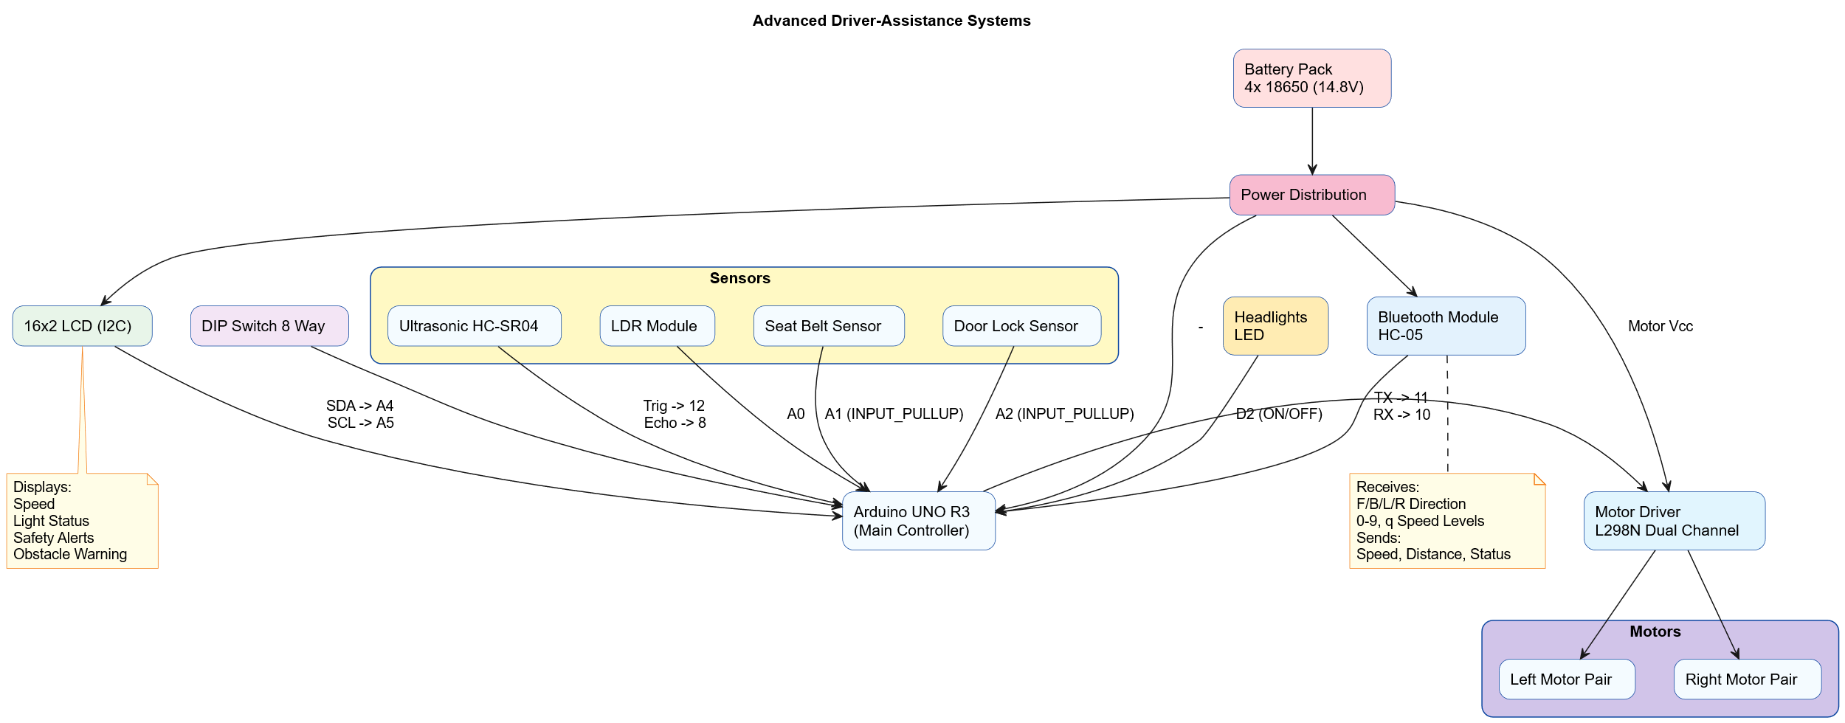
- Door Lock Sensor → A2

Program Modules with Comments
1. Initialization Module (setup())
- Initialize serial communication
- Initialize Bluetooth
- Initialize LCD
- Configure all I/O pins
- Display startup message

2. Main Control Loop (loop())
- Read Bluetooth command (direction + speed)
- Read LDR for light level
- Read ultrasonic sensor for distance
- Apply incremental speed update
- Perform safety validation
- Execute movement (Forward / Reverse / Turn / Stop)
- Update LCD with system status
- Send Bluetooth telemetry logs

3. Bluetooth Command Processing
- Receives Bluetooth command characters
- Converts characters 0–9 and q into PWM speed values
- Stores target speed in Speed variable
- Does NOT move the car — only updates speed reference
- Send report to the connected device about (speed, light and safety state)

4. Ultrasonic Distance & Safety Module
- Measure obstacle distance
- Calculate Time To Collision (TTC)
- Reduce speed automatically when TTC is unsafe

5. Speed Control Module (Smooth Acceleration)
- Adjust motor speed
- Updates every 40 ms to ensure smooth motion
- Prevent sudden braking
- Uses PWM on ENA and ENB pins

6. Movement Control Module
Command | Action
F | Move forward
B | Move backward
L | Turn left
R | Turn right
S / default | Stop

Motor Direction Logic:
Implemented using IN1–IN4 pin combinations.

7. LDR
- Detect surrounding light
- Turn headlights ON/OFF automatically

8. LCD Display Module
Displays:
- Speed
- Light status (ON/OFF)
- Safety state (SAFE / OBSTACLE)

9. Safety Buttons Sensors
- Check the seatbelt and door before moving
- The car can move if the door is closed and the seatbelt is fastened
- Otherwise, the car will not move.

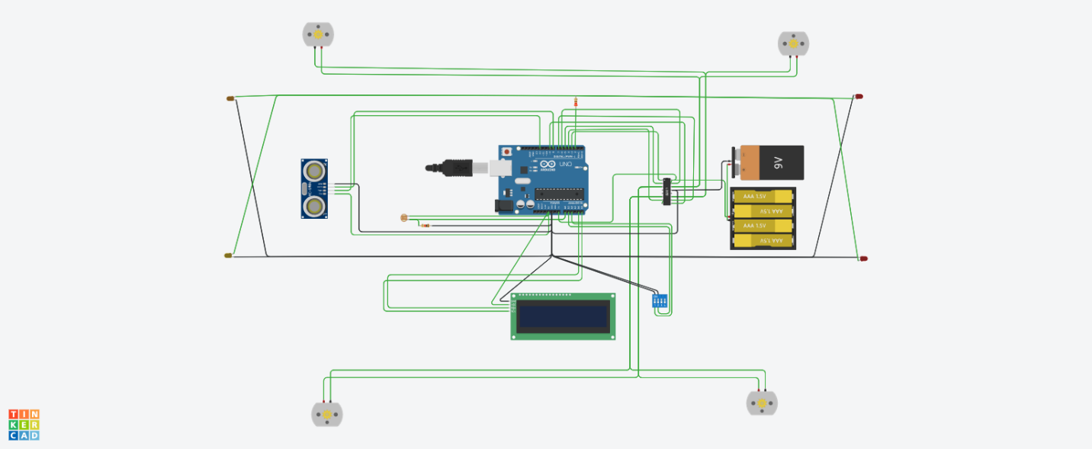https://www.tinkercad.com/things/biWAMIYXoqj-phase-1-project?sharecode=WANjqpi-d3QQBnAoKnWevCtdt4a--Y42-4BOKmglXJU&authuser=0

